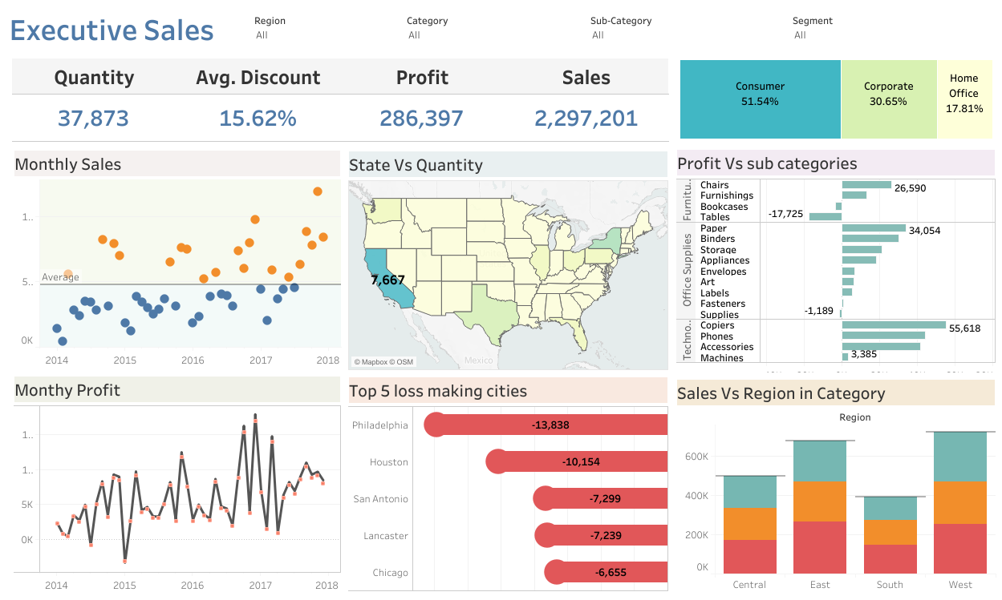

**Which is the region with the highest sales?**

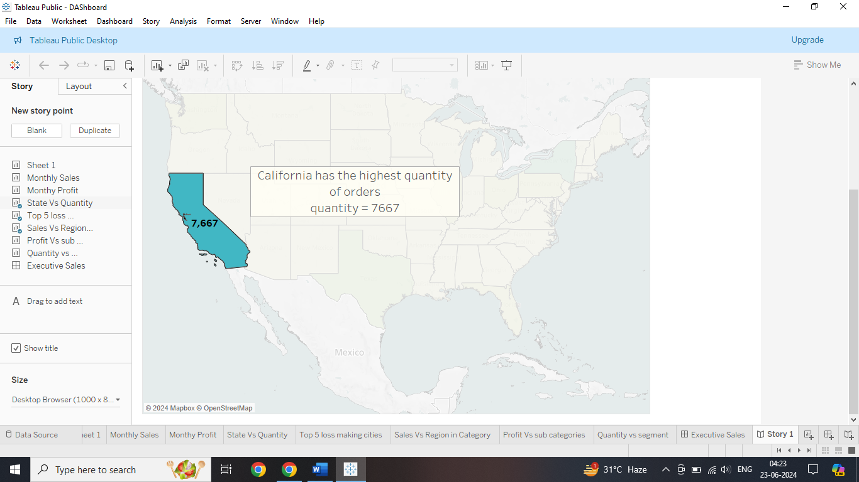

**Which is the region with the highest sales?**

**3) Name the category in the region with the highest sales.**

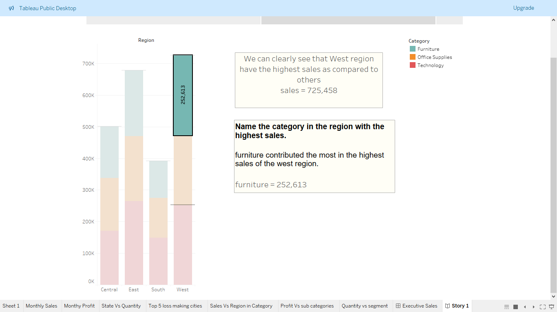

**Top 5 cities that bear maximum losses**

